

**SCHOOL OF COMPUTER SCIENCE**

**Container and Docker Security Lab**

**Submitted by**

|  |  |
| --- | --- |
| **Name** | **Vibhav Khaneja** |
| **Branch** | **BTech CSE(DevOps) B-1(NH)** |
| **Semester** | **5** |
| **SAPID** | **500105662** |
| **Roll no** | **R2142220297** |

**Lab Exercise 3: Working with Docker Volumes**

**Objective:**

* Learn how to create and manage Docker volumes.
* Understand how Docker volumes can be used to persist data across container restarts.
* Practice mounting Docker volumes to containers.

**Prerequisites:**

* Docker installed on your system.
* Basic understanding of Docker commands and container concepts.

**Step 1: Create a Docker Volume**

Create a new Docker volume:

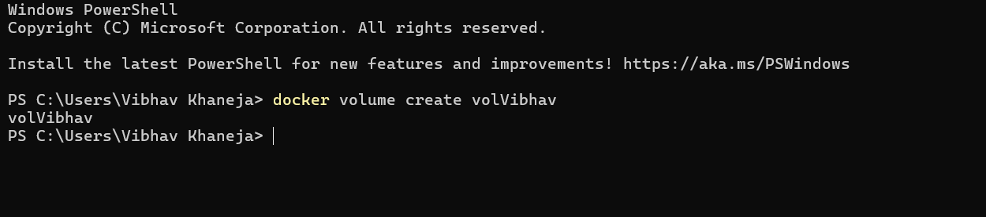

This command creates a Docker volume named volVibhav.

Verify that the volume was created:

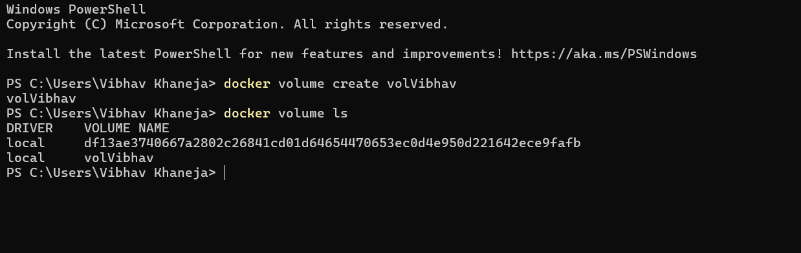

**Step 2: Run a Container with the Volume Mounted**

Run an Nginx container with the volume mounted:

docker run -d --name my_nginx -v volVibhav:/usr/share/nginx/html -p 8008:80 nginx

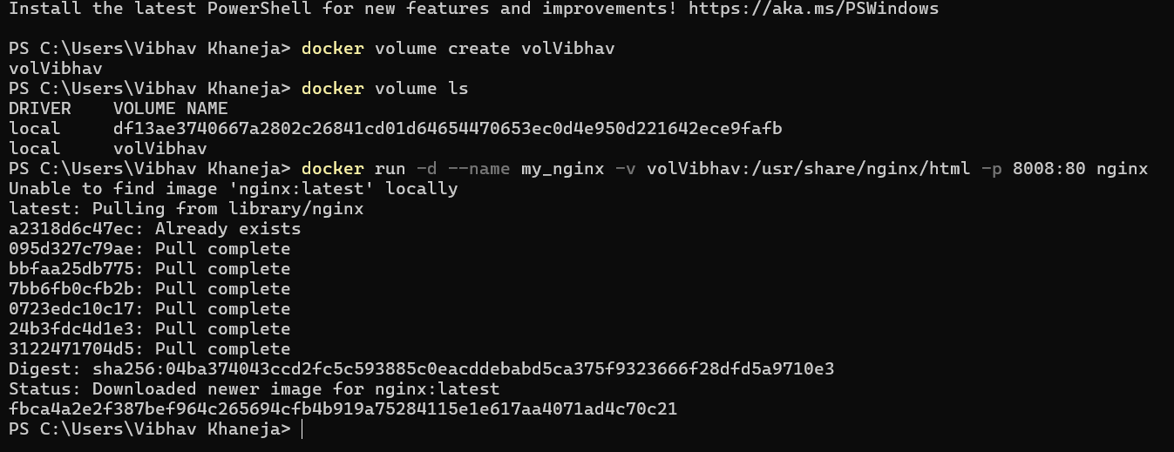

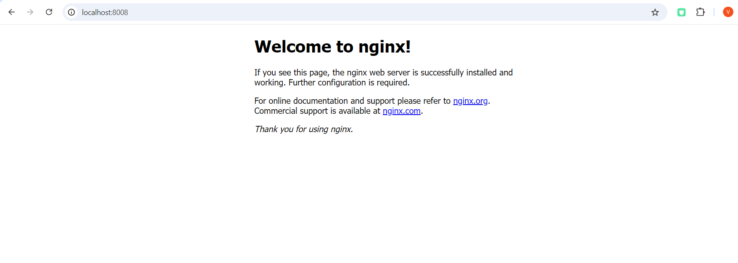

Verify that the container is running:

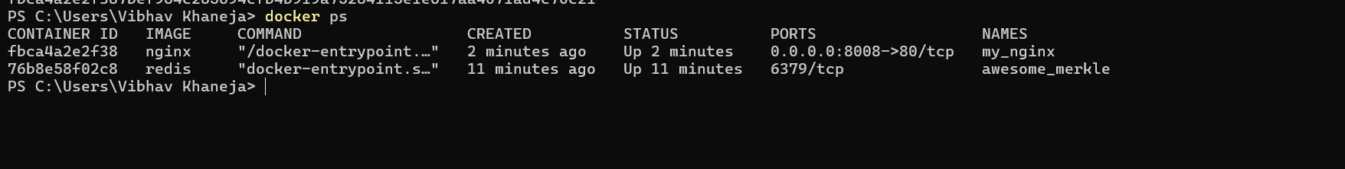

**Step 3: Interact with the Volume**

Create a simple HTML file in the volume:

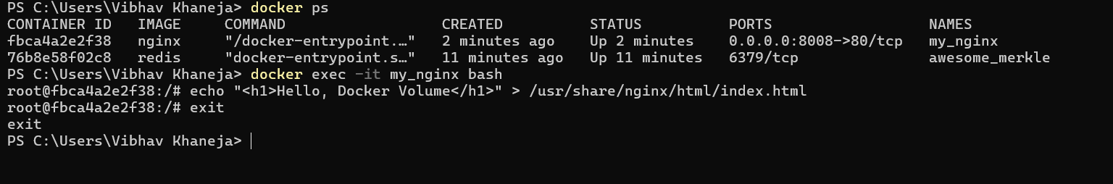

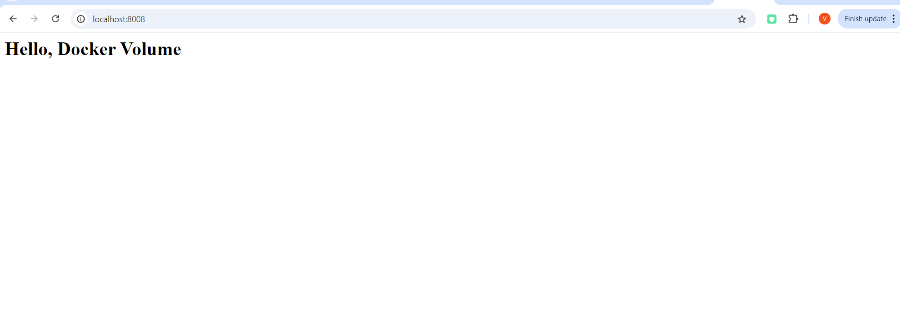

**Step 4: Test Data Persistence**

Stop and remove the container:

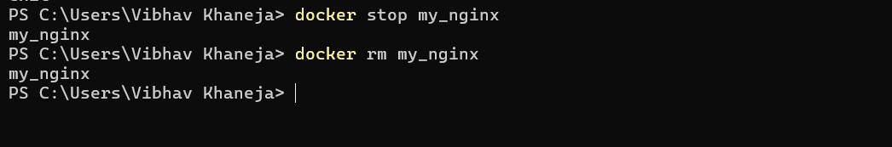

Run a new Nginx container using the same volume:

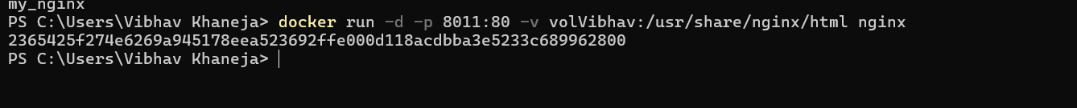

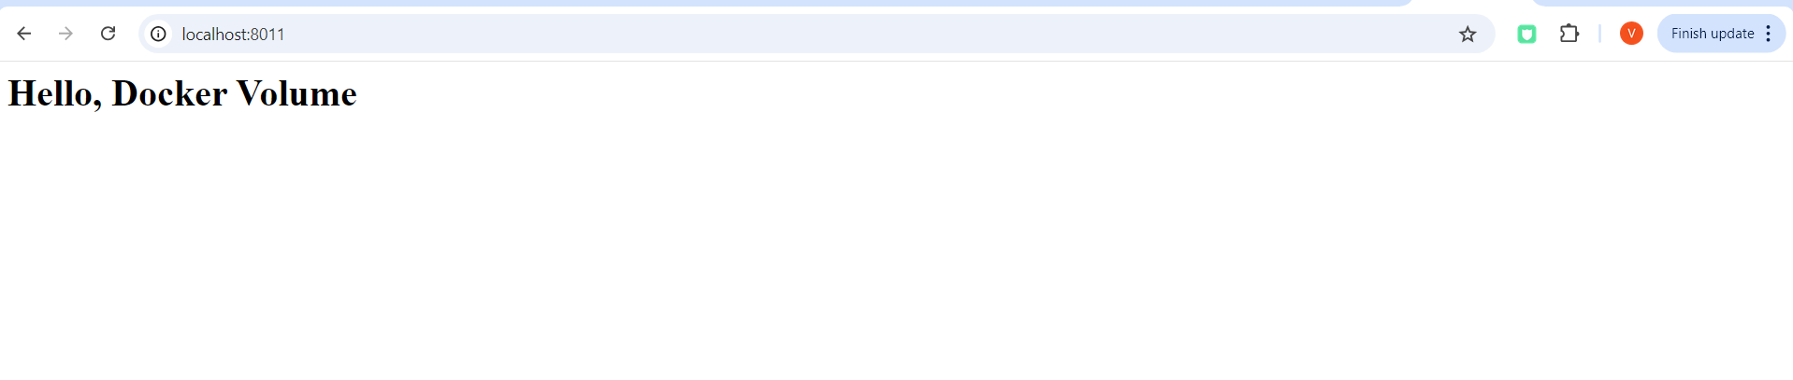

**Step 5: Clean Up**

Stop and remove the container:

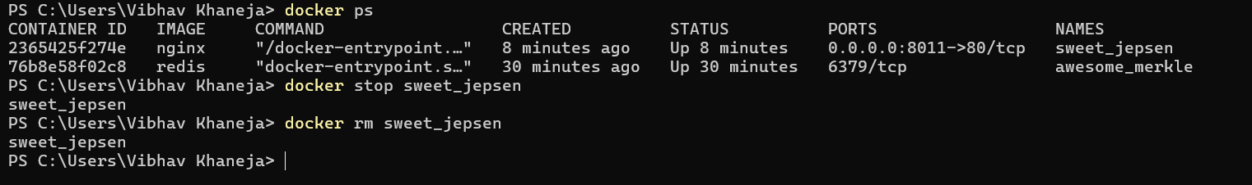

Remove the Docker volume:

